Good Luck in the London Marathon
KarenS, Sara, Rachael, Sharon and Antonia

Please can you all come to the club on Wednesday 20th April
wearing your London Marathon T Shirt and Medal.
Cameras will be ready ☺

East Hull 20

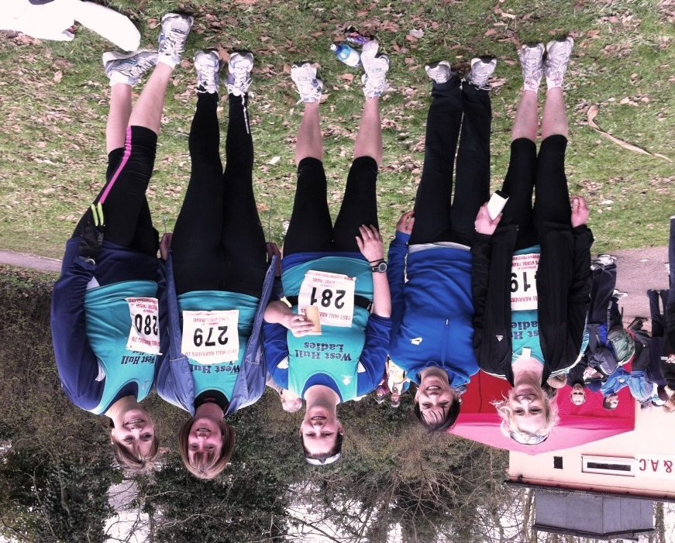
Sharon, Debbie, Karen, Sara and Rachael

We have some great writes ups this month from the inspiring East Hull 20s, the brave Verity on the Rudolph Romp to Emma having an epic on Lincoln 10K! Enjoy.

Marathon recovery

Marathon recovery begins the minute you cross the finish line. Keep walking at least 10 minutes after you cross the finish line to allow your body to return to its resting state gradually. Get your medal, take your photos, pick up your gear and keep walking. It will allow your heart rate and blood flow to return to its normal state as well as reduce the risk of blood pooling in your legs which can cause fainting. Get up and walk around 10 to 15 minutes every few hours for the rest of the day.

Refuel depleted muscles as soon as possible with a meal that includes carbohydrates, protein and sodium. Fuel is most efficiently absorbed in the first 30 to 60 minutes post-race. A peanut butter and jam sandwich, banana and sports drink is one example. If you struggle with eating post-race, try a liquid recovery drink. Recovery drinks are formulated with everything you need to refuel your body--carbohydrates, protein, electrolytes and fluid.

The stress of running a marathon can depress your immune system, leaving you susceptible to colds, flu and other upper respiratory tract infections in the days immediately following the race. Self-care is the best way to reduce your risk of contracting a virus, so make sure you get plenty of sleep, eat well-balanced meals and drink lots of water.

A general lack of energy in the week following marathon is perfectly usual. Try to eat meals comprising 50-60 per cent carbohydrates to replenish your glycogen reserves, and foods rich in protein to assist your body in repairing muscle and tissue. Indulge any cravings you might have – these could be your body’s way of telling you what it needs. Scientific research also indicates that many marathon runners lose around 3mg of iron per day for up to five days after the marathon, so eat foods rich in iron: meat, spinach, beans, peaches, parsley and peas during your post-marathon week. To promote iron absorption, drink orange juice or consume other rich sources of vitamin C with your meals.
Some runners complain of weight gain immediately after a marathon. This is most likely due to water retention as your muscles repair and rebuild. Don’t be tempted to start (or resume) any weight-loss regime during this time – your body requires a full complement of nutrients to recover from the stress of the race. Of course, if you are still gaining weight after your first recovery week, you might want to consider adjusting your calorie intake to suit your new activity levels.

Tapering in Reverse
Just as you tapered off with decreasing weekly mileage in the weeks just prior to the marathon you need to do the opposite after the race. Here is a typical post race schedule:
Week 1:
Mon | Tue | Wed | Thu | Fri | Sat | Sun
Walk | Walk | 3M | Walk | Rest | 4M | Walk
Week 2:
Mon | Tue | Wed | Thu | Fri | Sat | Sun
3M | Rest | 5M | Walk | Rest | 6M | Walk

WEST HULL LADIES RRC
COMMITTEE MEETING MINUTES 04.04.2011

Attendees: Amanda Dean, Verity Pick, Rebecca King, Jo Townsend, Katy Snow and Louise Ede
Apologies: Victoria Voase, Annette Pearson, Geri Wright

Membership
It was decided that our membership would now run from 1st April – 31st March to tie in with the England Athletics memberships. There are still some ladies that have not paid the fees for this current year. LE confirming England Athletics require their fees paid by 30th April 2011. All ladies who have not paid membership by this date will be removed from our distribution list and deleted from the England Athletics website as a member of WHL.

Events
KS confirmed that she would circulate an e-mail about meeting up for drinks over the Bank Holiday weekends. It was also suggested that perhaps a picnic could be arranged, whereby ladies would meet for a run and then stay for the picnic afterwards.

Next Meeting – Monday 9th May 2011

April Muscle of the Month: External and internal obliques

Where is it? The external obliques attach to the bottom 8 ribs and go down to attach to the pelvis. The internal obliques attach to the top part of the pelvis as well as the inguinal ligament in the groin and go upwards to attach to the bottom 4 ribs.
What is it and what does it do? The obliques laterally flex the trunk (i.e. they help us bend to one side and then the other). They are also vital in supporting the abdominal viscera and the internal obliques are important muscles used in respiration.

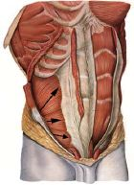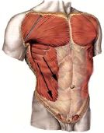
Internal obliques External obliques

How does it get injured? As with rectus abdominis, these muscles can be injured through a number of sports, and injuries can be very painful indeed. Be careful when working the obliques at the gym through sit-ups on a diagonal. Excessive arm movements whilst running can injure these muscles so check that your arms are nice and relaxed whilst running.
How can these be treated? Rest is the best way to treat abdominal strains, although massage can also help enormously.
How do I stretch it? Lean backwards over a pilates ball and keep this position for around 30 seconds, or lean over to one side, stretching the injured side.
How do I strengthen it? Although sit-ups are the most common type of exercise for the abdominal muscles, I prefer people to do the side plank as it puts less strain on the neck and back. The plank need only be held for a maximum of 30 seconds each side to do all the work your obliques need.
Which muscle groups are related to it? Other abdominal muscles such as rectus abdominis, but also the back muscles (erector spinae, QL, etc) as they counter the work of the abdominals.
Did you know....? In humans and other vertebrates, there is a white dividing line which splits the abdominal muscles, called the linea alba – literally white line. It is basically a fibrous structure made up of connective collagen tissue. It is commonly used as an incision point for abdominal surgery due to its lack of nerves or blood supply. It has been known to split when excessive strain is put upon it, for example
through obesity. It is an important attachment point for abdominal muscles and aponeuroses.

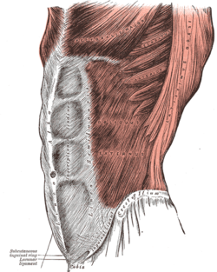

About me
I am an Advanced Remedial Massage and Manipulative therapist based in Cottingham, Hull and Beverley. I treat a variety of sports people in my clinics and I am always delighted to treat members of the West Hull Ladies running club so if you would like to book an appointment or have any questions, you can email me at kirstieannskelton@hotmail.com, call 07789 914597 or visit my website www.kirstieannskelton.com for further details.

Race Write-Ups or Write-Offs:

East Hull 20

KarenS: How different a training run and race can be...I started off with Rachael and Sara and felt ok until about 5 miles when I told them I needed to slow down. So I just carried on in my own little world - no music - just my own thoughts to keep me going. Right knee started playing up and about half way Gill and Sharon had caught me up. Gill had some tablets on her which she gave me to help with the pain - thank you Gill!! - and with that I carried on again. 16 miles was my sticking point as some runners were starting to walk and I was determined not to. I never have before so it just shows how much mentally stronger I've become since starting marathon training. Heading towards the finish line I was overcome with emotion - I think this was down to my knee playing up and yet again the achievement of running 20 miles. As I approached the finish all I could hear was our ladies cheering me in - another thank you to Katy and Geri for coming to support us - which meant so much as I didn't think anyone would still be there. With that I had a tiny cry as I was so overcome with emotion...what am I going to be like when I finish London?? I will be a blubbering wreck...

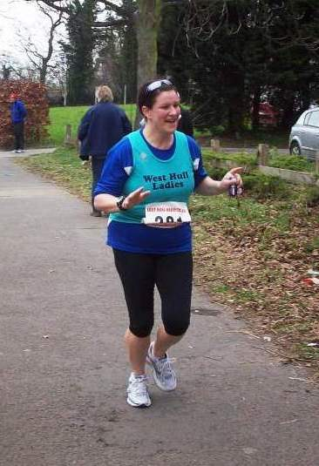

Sara: I was quite nervous in the morning but once we arrived and were at the start I felt fine. We made sure that we set off at a steady pace and did not get carried away with the crowd. We soon settled down and started to enjoy the scenery of the route - it made a nice change to run somewhere totally different. Rach and I both felt strong and were quite surprised at how many people we started to overtake after the 15 mile marker. At 17 miles we stopped and walked briefly whilst we had our energy drink and some food and to our surprise we turned around and there was Sharon - Sharon joined us for 2 miles and at 19 she took off and sped away to the finish! Well done Sharon. Rach and I crossed the line at 3hrs 17 mins which we were really pleased with as in training we did our first 20 miles in 3.33. We both now feel really confident that we can complete the marathon and hopefully within a reasonable time. Thankyou to Geri, Katy and Amanda who turned up to cheer us in at the end.

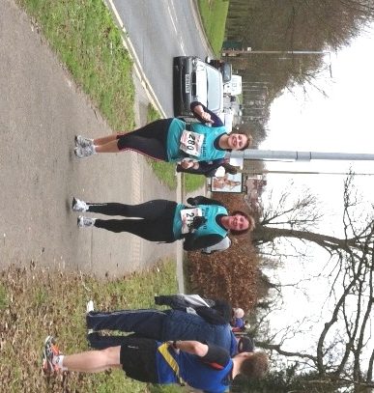
Rachael: Would just like to say well done to all the ladies on Sunday, Sara and I had a great run felt strong and managed to keep a steady pace throughout, had good conversation and the time really passed. Sara is great at planning routes for our running in our circle of friends we call her Molly Maps because she is so good at map reading and planning, so it was nice for her to have a route planned out. Sharon is like a little rocket at the moment, Sara and I were running along the at the 17mile mark when we heard a little ooh turned round and motoring up was Sharon, looking full of beans and on fire, she ran with us for a while then broke away just before the 19th mile, she was great. We would also like to thank Debbie for running with us the last three weeks, Sara and I both agreed that she has increased our pace so a very big thank you to her she is a true inspiration. Karen was great she set off with Sara and I but it is hard to stick together on the busy roads, it was great to see her cross the finishing line in a good time good luck for London Karen know you can do it girl, and finally poor Gill I really do feel for her but look on the bright side you did do 15miles which is a great. Thanks to Geri, Katy, Amanda and Susan and husband for the great cheering at the end it does make you feel great when there are people at the end cheering for you.

Debbie: My plan for this year’s EH20 was to come in under 3hours and not exhaust myself in the process. I decided not to run in vest and shorts but opted for a long sleeve dri-fit top under my vest and thin leggings, I set off at a comfortable pace and fell into step with some ladies from Cleethorpes and then a lady from Saddleworth, we ran together for about 7 miles and were pushing sub 8.30 m/m we passed 6miles just over 50mins, I began to think it was probably a bit fast to maintain but carried on. (I was also regretting the long sleeve top and leggings at this point) At 8 miles I had problems with my breathing, and started wheezing! this can be an on off pain for me when the pollen starts to come out and as the EH20 is in the country I think I was inhaling some. I stepped back a bit and drank some of my drink and had a few jelly babies, miles 8 to 10 were not comfortable, I ignored the weird noise I was making and felt physically strong.
At this point, I appreciated Dave Brookes cheering me on from his bicycle.

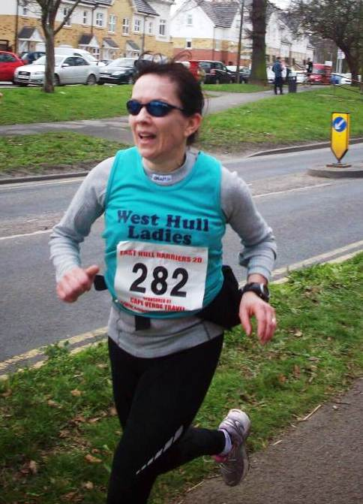

I kept my fluid levels up and had some rather mushy banana and began to feel better. At 11 miles I decided to up my pace a bit, I still had the
Saddleworth lady in my sights and my aim was to catch up with her eventually. The Cleethorpes gang passed me and so did a few others, however I was not too disillusioned and kept plugging away, at this point I was glad of my extra clothing as I had begun to cool down and we were heading into a bit of a wind. At mile 15 the marshall said 2hours and 12 and I thought I have to get in under three hours so I upped my pace at bit more and eventually caught up with the lady from Saddleworth who was very tired. My breathing had settled and I just kept telling myself I was strong and super! I don't remember much of the last 4 miles I think I was on automatic pilot at this point, the hill at the end seemed longer than last year. I had a bit of a race down the hill with a youngster from Beverley and was relieved to see the clock at 2.58.34, the rest is a bit of a blur

It was lovely to see Amanda, Geri and Katy at the end. The marshals were really encouraging on the course and I appreciated shouts of 'well done west hull', they really kept me going.

Sharon: The day started off well with both Gill and I in good spirits, taking it steady. Although Gill was in some discomfort with her leg, she didn’t feel too bad, it was when she took painkillers at 10 miles she started to feel unwell and told me to run on. I was very reluctant to leave her but she insisted, there were plenty of people about.

So I carried on, at that point, not many running in view ahead. I felt OK and increased my pace and started to catch up with people. Then I spotted Sara and Rachael in the distance and caught up with them. We ran together for a while then I suddenly felt the urge to take off and run the last couple of miles or so faster, up the dreaded hill that I’d suffered miserably on during the Boxing Day 10K run. This time no problem. Then carried on to the finish still feeling there was more in the tank!!

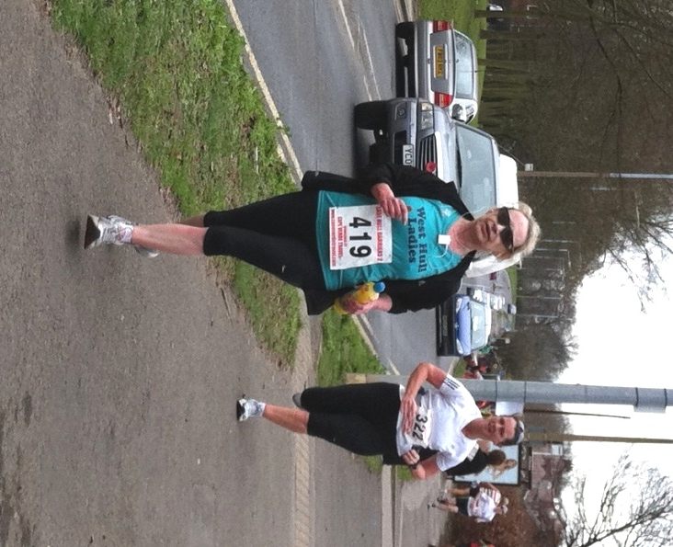

Gill was unable to train with me after the East Hull 20 because her injury was much worse. It was really tough training without her.

Can I say a big thank you to Rachael and Sara for welcoming me on their training runs through the following weeks and weekends. xx

Rudolph Romp
24 Miles Off-Road

Verity: I don’t mind admitting that I was nervous about Rudolph’s Romp. The idea of attempting to run the best part of 24 miles did not fill me with the joys of spring. And it certainly didn’t feel like spring at 8am on Saturday 5th March.
At the mass start, I felt somewhat sorry for the volunteer who had to do the safety briefing. I thought it was just big groups of teenagers that can’t be quiet, but it turns out that runners are just as bad. I had to fight the urge to shush the talkers in a teacher style! I have no idea what the poor chap was on about but I stood there dutifully staring at him like he was in a silent movie.
As soon as we set off I knew that tying my mug to my Camelbak was a bad idea. I sounded like Heidi as I ran along with a cow bell attached to my back. A fellow runner commented that if he got lost he could just listen out for me.
Leaving Brantingham, the scenery is beautiful and there was a good atmosphere amongst the runner/walkers. I had always planned to walk the hills, and was determined not to get carried away by running up the first few steep sections. Having said that, I was really disappointed when I reached the 6 mile checkpoint in 90 minutes. I was having trouble with my equipment and, leaving the checkpoint, I kept the couple behind me amused as I steadily dropped and had to retrieve my hat, then my left glove, then my right glove, then my map!
I pulled myself together, and managed to complete the next 6 miles in 60 minutes. I was really pleased that I managed to run all of the section (it was pretty much flat) I was worried because my feet started to hurt at about mile 9/10 and of course, the first thing you think is, “Can I cope with this pain for another 14 miles?” Fortunately, the magical Ibuprofen kicked in pretty quick and it eased off. Phew!
I loved the bit through the trees, it was pretty boggy but that’s the fun of off-road I suppose; no point spending money on trail shoes if you’re not gonna need them! Running out of Sancton I needed some motivation so I plugged myself into my iPod; there’s nothing like a bit of Bonnie Tyler to keep you going. The gorgeous scenery continued and I was feeling strong as I headed to check point 7 at Arras Wold. This was where the recces really paid off; knowing where to walk and where to push on kept me going along with the genius of the Glee cast sound track at this point.
At check point 8 (16 miles) I met two ladies who were of a similar pace to me. They were first timers to Rudolph’s too, and weren’t very sure of the route so I tried to be confident in taking the lead. Pushing up to High Hunsley was not fun but it was a great feeling to get to the highest point of the run. The next check point was supposedly at 20 miles but it took over an hour from the 16 mile point and we hadn’t walked that much. Leaving the 20 mile point, we faced the last big hill, the aptly named ‘Steep Hill Road.” Seeing the Brantingham village sign on the way back was the most wonderful sight and I pushed for home to the sound of the lovely Cheryl Cole. What a finish! I just had enough energy left to hand in my race card and ask for a cup of tea!
Rudolph’s Romp is a lot of fun; I recommend it to anyone who likes off road running. The sense of achievement was immense. I’m very proud of my certificate and my badge!

Lincoln 10K

Emma: The race I should have never run!

All the signs were there telling me not to run this race, but I’m pleased to say I did and (unofficially) beat my previous PB of 55.03 by running 52.30.

Over the last two weeks a mixture of busy times at work and illness has meant I haven’t ran at all. I’ve got a bad cold and Dave a bad knee, so he was definitely out. I asked my mum (who I have been trying to persuade to join the club!) if she wanted to run in his place as a mother’s day treat, and she agreed! She’s only ever run Race for Life, although has been training for a 10k, so I thought if she can do it – so can I!

Still not feeling 100% on race morning, I tried to put on a brave face for my mum as she was full of nervous excitement. We thought we set off with plenty of time and had directions to the official car park, only to find when we arrived that all the roads leading to the official car park were closed! Nightmare! Finally found a Charity Car park in a local school, but already running late and further from the start than we anticipated, we quickly pinned our race numbers on and headed to the start. Almost at the start my mum joked “Can’t we just wait here and join the runners as they go past!” “Don’t be silly” I replied “Our chips won’t work…..AARRGGH OUR CHIPS ARE IN THE CAR!” We’d already been walking 20minutes and there was no way we could have made it back so unfortunately we ran ‘chipless’!

I did manage to slip into the sub 50 zone as planned whilst my mum headed to the 60+ area. I tried to enjoy the run, but really struggled and was so cross with myself for leaving the chips in the car! To make matters worse my stopwatch didn’t work properly, so my time is the race time as I finished. Other than the car parking fiasco, it seemed like a pleasant and well organised race, and the runners around me were all running a similar pace, something I’ve never experienced before! I was aiming for sub 50, but with my cold and lack of training, am trying to be pleased with a new PB of 52.30mins.

I do have some good news however - although she found it really hard, my mum loved it and finished her first 10k in 1hr 13mins (including a toilet stop!) and has agreed to join the club! Look out for her on Friday!

LouiseW Really enjoyed the Lincoln 10k today! I haven't raced for about a year due to injury and so I was getting a bit jittery about the whole thing. With this in mind, I decided to run without a watch or any time goals. This worked really well for me as I just focused on running comfortably and enjoying the experience. Sadly this means that I don't have an idea of my time and can't find out until tomorrow when they go online but I think that it will be about 55 - 56 minutes. I will keep you posted! (56:40)

Hornsea Third Marathon

Amanda: I was hoping to go sub the hour on this race. It is 8.73 miles and 2 years ago I managed 60:30. It is all down to training and I had been trying pretty hard and feeling fit and healthy. I was expecting to be on my own at the race and was really pleased to find Yendis, KarenC, Antonia, Stella plus Annette and AmandaC supporting husbands (and us). Chatting to others settles me down. The conditions were good, warm. I raced in vest and shorts for the first time this year. It was windy, but could have been worse.

I placed myself behind the front runners choosing someone I knew would be fast so I wouldn’t suddenly be tripping over a slow runner who had decided they wanted to be on the front line. The first mile was fast – I think it must be downhill with back wind ... or is it the adrenalin? Then I settled in. A very young skinny girl flew past, I wondered if I would pull her back later. A mile later and a young, strong looking woman, pulled past, I knew I would be unlikely to catch her again. Then City of Hull lady, about my age, pulled past and for the next few miles I gained on her and she pulled away and I gained again, but never caught her. My planned pace was on target for the first few miles but dropped off, not too daunted as I had left a minute in reserve. However, by mile 7, this was possibly not enough in reserve, but still optimistic that I could find something special.

I picked off the ‘very young skinny girl’ just after the 7 mile marker and felt bad. She had done so well and was so young, but I wanted to get sub 60 mins and had to keep pushing on. I was trying to work harder, ‘City of Hull lady’ was ahead and for a while I was getting closer then, even though I was working harder, she was pulling even more out of the bag. 8 mile marker, 55 mins and something. Maths streaming through my head. Can I run 0.73 miles in 4.5 mins? Never did work it out, but switched to concentrating on form and keeping going as best I could. End in sight and gave it more. Finally through the funnel and heard 15 seconds called. Aw! I had missed it! 60mins and 15secs. But I was third lady and it was a PB. and ... if I had made sub 60mins, what would I have to aim at next year? So fab J . Chatted to ‘City of Hull lady’ then congratulated ‘very young skinny girl’ who is just 17 years. I told her she was really good for her age and would be beating me by next year .... and she will.

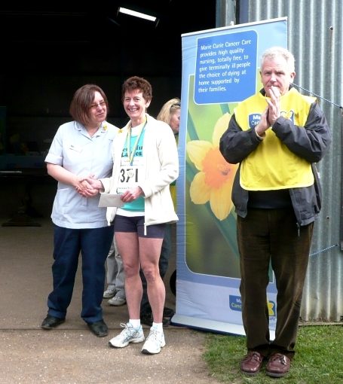

Amanda receiving 3rd Lady Prize from Marie Curie Care Nurse.

This is a very pleasant race. Undulating, quiet country roads. It is an event for Marie Curie which is a fantastic charity. It attracts a wide range of strong runners as well as charity runners. A nice goody bag with a banana, bottle water, 3 mini chocolate bars, a T Shirt, a medal and a box of ‘Sport Joint Care’ tablets (very useful).
The farm is a lovely location and you can buy free range eggs and go visit the hens if you wish. There is a snack bar and it is well organised. I like this distance and would recommend it as a lovely race for someone stepping up from 10K races.

Racing and Running Events

2011 | Date | Time | Event | Distance | Fee | Notes
Apr | 10th | 09:00 | The Brighton Marathon | 26 miles | - | -
Apr | 16th+17 | 08:00 | The Woldsman Challenge Walk | 50 miles | £14 | None
Apr | 17th | - | The London Marathon | 26 miles | - | -
Apr | 24th | 10:00 | Helmsley Multi-Terrain Challenge | 10K | £10 | Enter online
Apr | 30th | 10:00 | Yorkshire 3 Peaks Fell Race | - | - | Entries closed
May | 1st | 14:00 | Kirkbymoorside | 10K | £8 | Enter online at UKResults
May | 2nd | 09:30 | Rothwell | 10K | £12 or £15 OTD | Enter online at UKResults
May | 8th | 11:15 | Beverley 10K | 10K | £12 | 10K entry online only  FULL
May | 8th | 09:30 | Sheffield | Half Marathon (Fun Run also) | £21 | Enter online
May | 8th | 09:30 | Leeds | Half Marathon | £20 | Enter onlineEntries close 8th April
May | 15th | 09:00 | Hull | Jane Tomlinson 10K | £20 | Enter online
May | 15th | Morning (staggered) | Manchester Great Run | 10K | - | Charity places still available
May | 15th | 09:30 | Ravenscar | Half Marathon | £10 in advance | Entry by post only
June | 5th | Ladies: 10:30; Men: 11:00 | Harewood House Chase | 10K (Trail and Road) | £8.50 | Entry by post only
June | 5th | 11:00 | The Humber Bridge 10K | 10K | £10 | Online entry
June | 5th | 11:00 | Goole Viking Striders River Bank Challenge | 1/3 marathon approx | £9 | Postal entries close 28th May
June | 19th | 11:00 | Leeds 10K Run for All | 10K | £9 | -
July | Friday 8th | 7:30pm | Walkington | 10K | £11 | Online entry
** Dates/times are subject to change **
Keep checking the website for new races and updates: www.westhullladies.org.uk/races.htm Verity, Racing Officer

NOTE: Club Vests must be worn at any races you enter
under the West Hull Ladies running club name.

Clubwear
PRICES:
Vest | £15.00 | All items are ordered on request and must  be paid for at time of ordering. To place an  order please get in touch via West  Hull Ladies e-mail and mark your emails  for the attention of Geri.
T- shirt | £16.50
Hoodie | £14.00
Jacket | £32
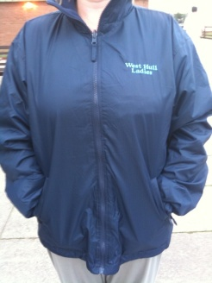

New Club Jacket available in three sizes: small, extra small, and junior (large fitting). If you would like to purchase one please send a cheque for £32 to Victoria Voase, Treasurer, and state on the back of your cheque your name and that the cheque is for a jacket.

Becca

Running Library

Email the club if you wish to borrow any of the books.
Book List:
- The Runner's Diet (Runners World), Madelyn H. Fernstrom
- Paula My Story So Far, Paula Radcliffe
- The Runner's Handbook, Bob Glover
- The Competitive Runner's Handbook, Bob Glover & Shelly Lynn Glover
- Marathon Running For Mortals, John Bingham
- Lore of Running,

Running Magazines: These are available to borrow by emailing the club website.
Mark your email for the attention of Becca.


